***Report On***

***PIR BASED SECURITY ALARM USING 555 TIMER***

**Introduction**

This is the PIR-based Security Alarm System, in which a PIR sensor is used for detecting the intruder. An alarm is generated if any motion of the person is detected. PIR sensor triggers the 555 timer which generates an alarm if a person is detected.

In this project, a Schematic design & PCB Layout for the circuit that will generate an alarm on motion detection using 555 Timer is designed.

It will switch on the buzzer for some time interval of time if motion is detected.

**LM 555 Timer**

The 555 Timer is a commonly used IC designed to produce a variety of output waveforms with the addition of an external RC network.

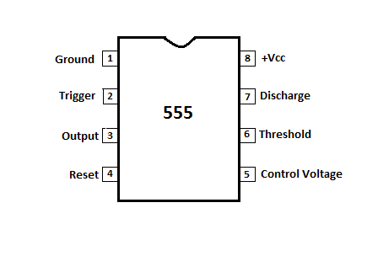

**555 Timer Pin Diagram**

**Circuit Description**

The PIR Sensor Security Alarm System is built based on a simple concept and it has few key components. The key components are the PIR motion sensor, Transistor BC547, 555 Timer IC and Buzzer. The PIR sensor is used to detect motion. When the PIR Sensor detects any human body movement, its OUTPUT pin becomes HIGH. Then this High output will go to the BC547 Transistor. Then the transistor will connect the trigger pin of the 555 timer IC to the ground. Now the timer IC produces output, which turns on the buzzer.

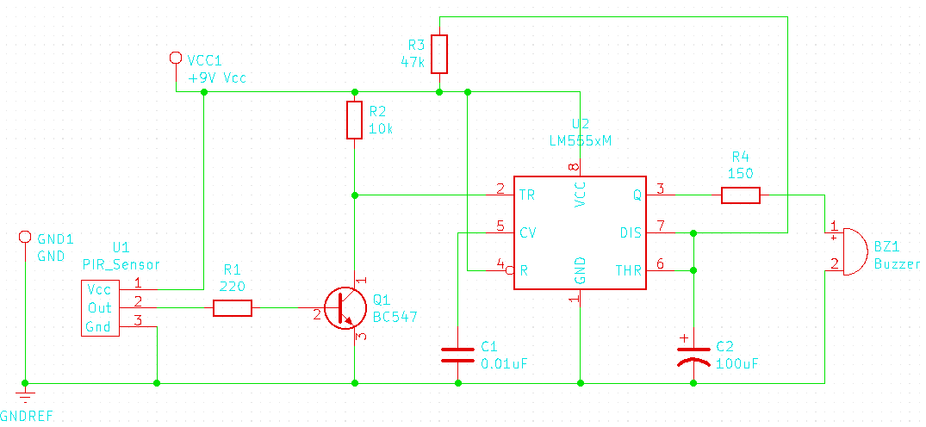

**CIRCUIT DIAGRAM**

**Operation**

When the PIR Sensor detects any human body movement, its OUTPUT pin becomes HIGH (Vcc) and when it does not detect any human body movement, its OUTPUT pin becomes LOW (Ground). Here the BC547 Transistor work as a switch. When the voltage applied at the base terminal of it, it is turn ON and otherwise, it is off. In this circuit, the 555 timer IC configured in monostable mode, so when it gets a LOW (Ground) trigger pulse at its trigger pin, then the IC OUTPUT becomes High.

**PIR sensor detect motion**

When anyone passes in front of the sensor, then the sensor provides high output voltage. This output voltage goes to the base terminal of the BC547 Transistor, then the transistor is turn ON. In this condition, the 555 Timer IC trigger (Pin 2) is connected to the ground through the transistor and gets LOW (Ground) trigger pulse. So, the Timer IC Provides output voltage, which goes to the Buzzer. Then the buzzer is turn ON and produces loud sounds.

**PIR sensor does not detect motion**

When the PIR sensor does not detect any motion, then the sensor provides low (0) output voltage. This output voltage is not sufficient to turn ON the BC547 Transistor, it means the transistor is OFF. In this condition, 555 Timer IC trigger (Pin 2) does not get LOW (Ground) trigger pulse. So, the Timer IC does not provide output voltage.  So, the buzzer is also OFF.

**Conclusion**

In this project, PIR-based Security Alarm System, in which a PIR sensor is used for detecting the intruder. An alarm is generated if any motion of the person is detected. PIR sensor triggers the 555 timer which generates an alarm if a person is detected.